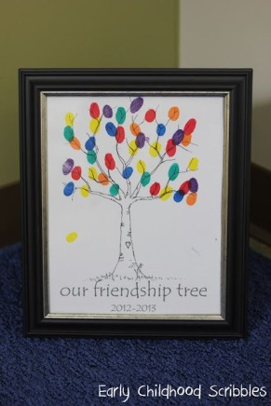



Our friendship tree

January 2017



Our friendship tree

January 2017